a)

|  |  |  |  |  |
| --- | --- | --- | --- | --- |
|  | R1 | R2 | C1 | C2 |
| Q = .5 | 15.1 kΩ | 15.1k Ω | 10 nF | 10 nF |
| Q = .25 | 1.51 kΩ | 50 Ω | 1 µF | .47 µF |
| Q = .1 | 1.51 kΩ | 50 Ω | 1 µF | .47 µF |
| Q = 1 | 2000 Ω | 100 Ω | 10 µF | 1 µF |
| Q = 2.5 | 1.51 kΩ | 50 Ω | 1 µF | µF |

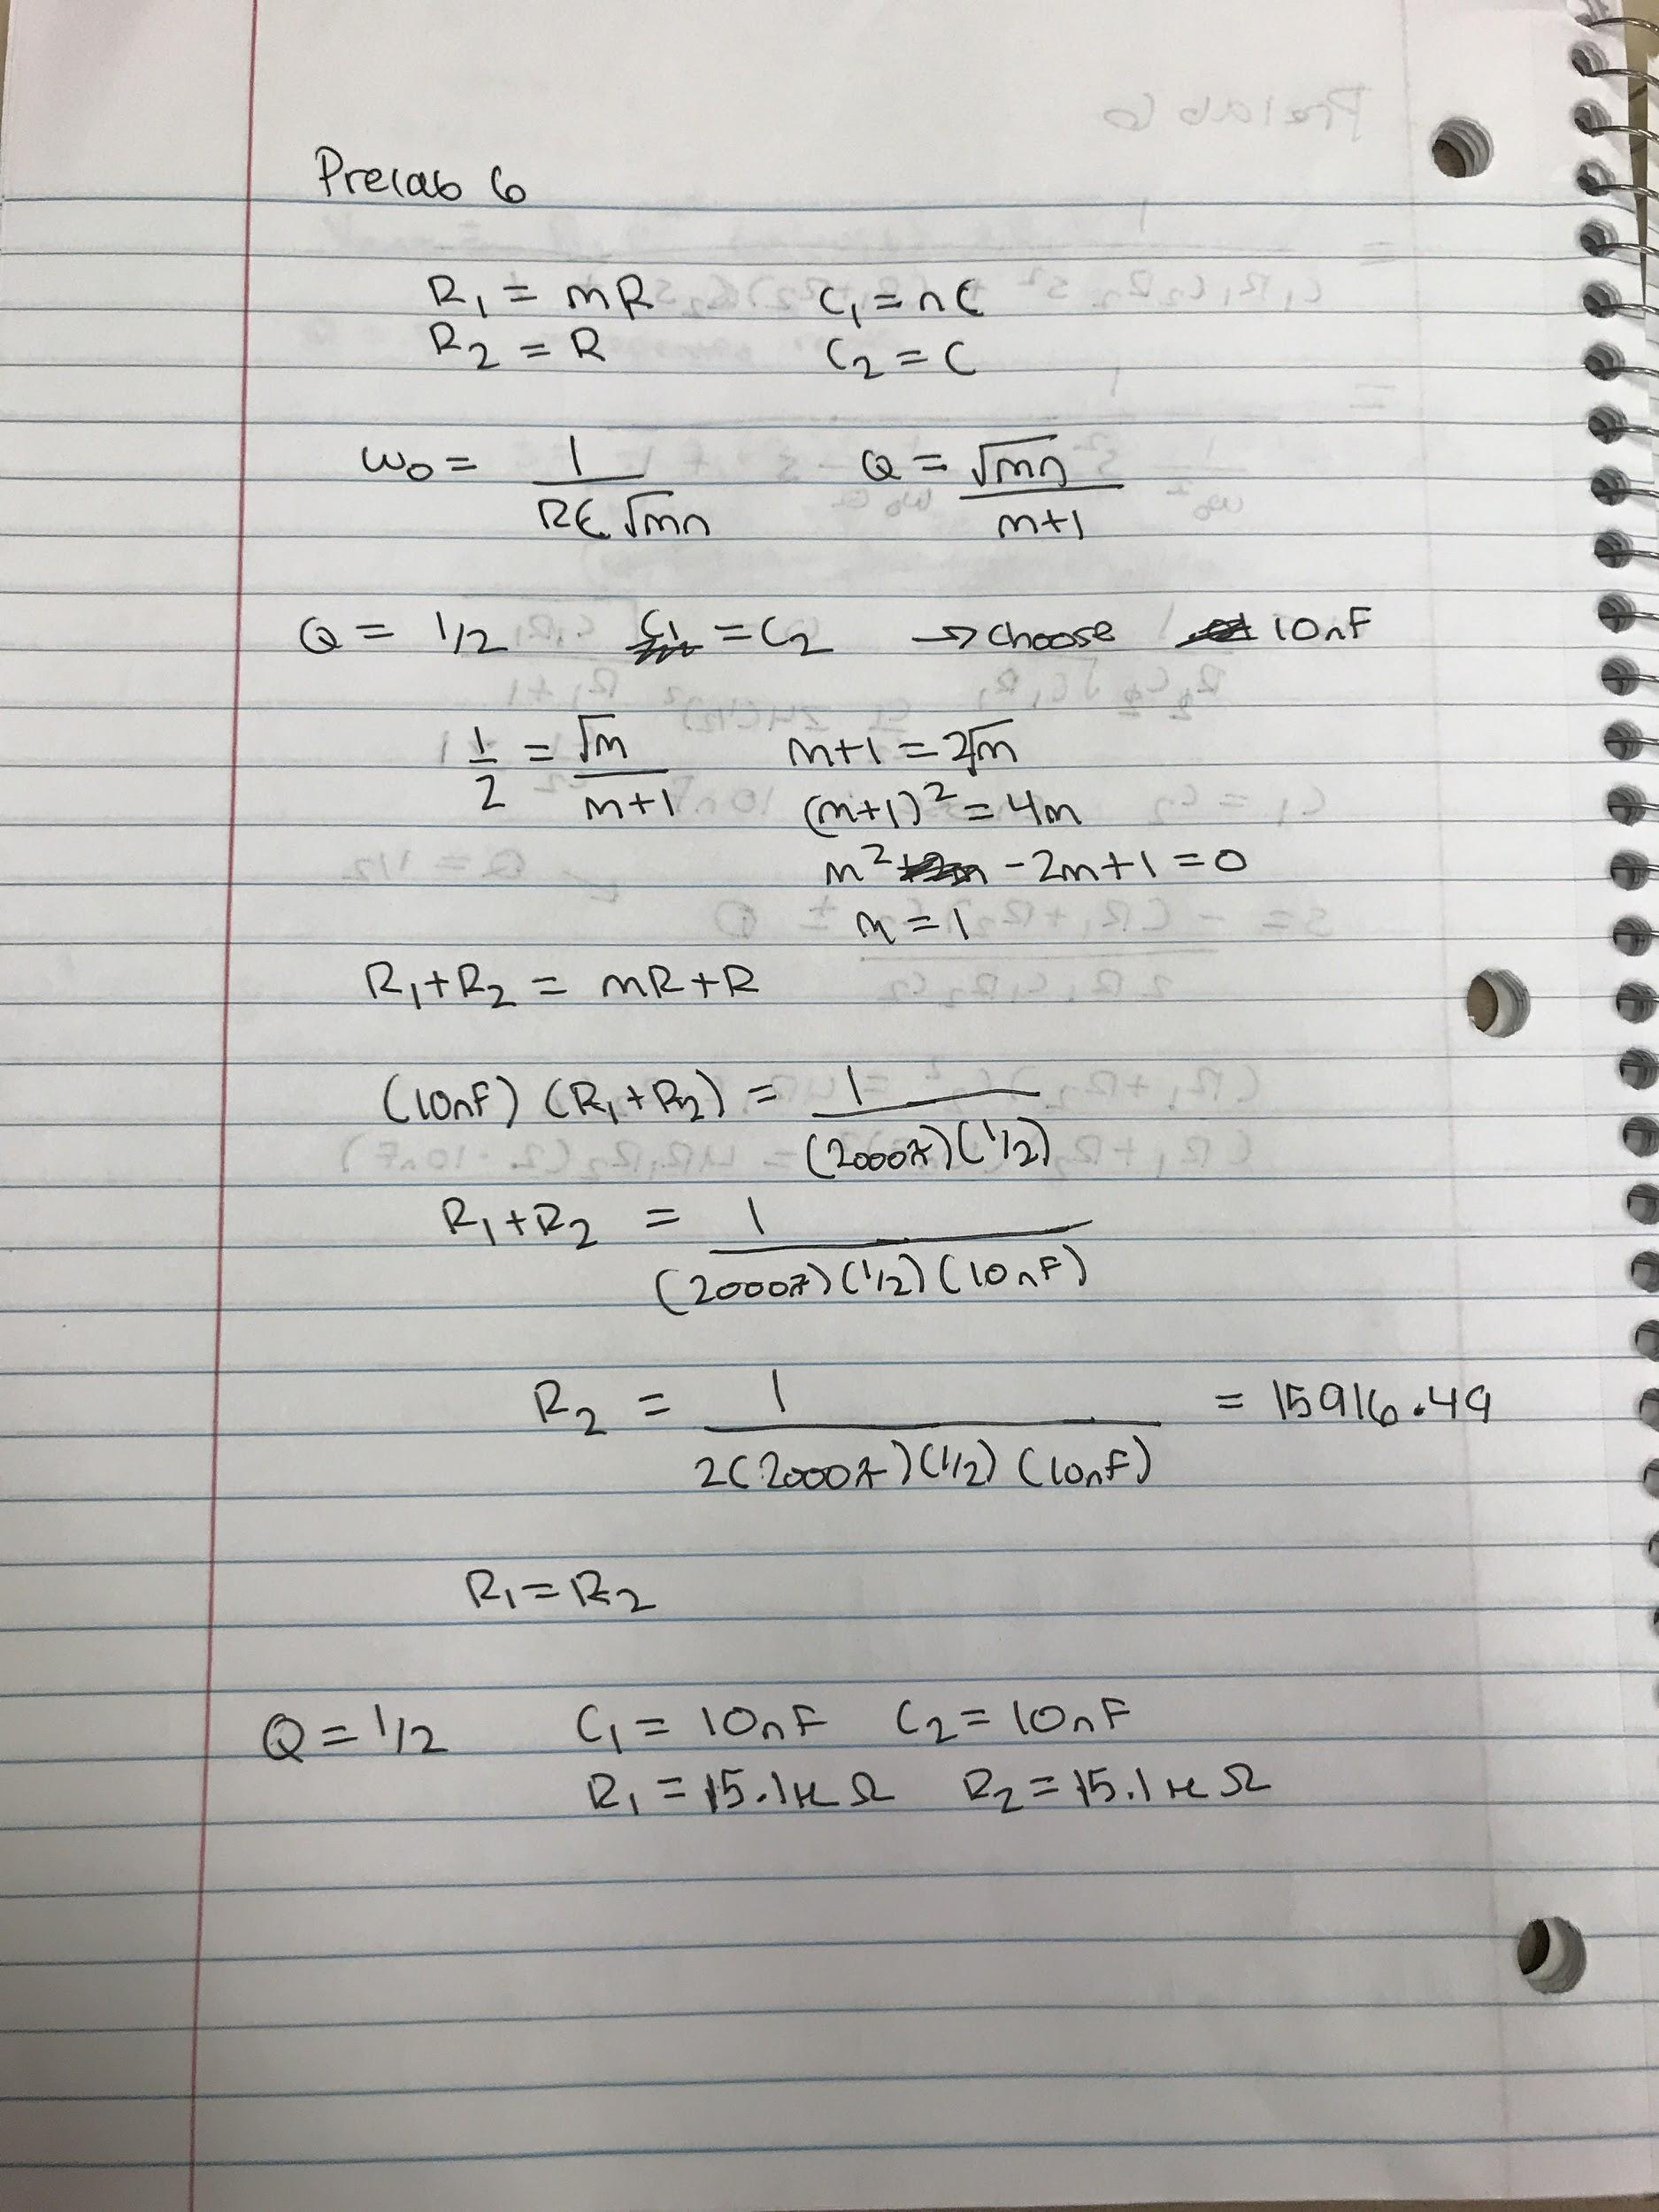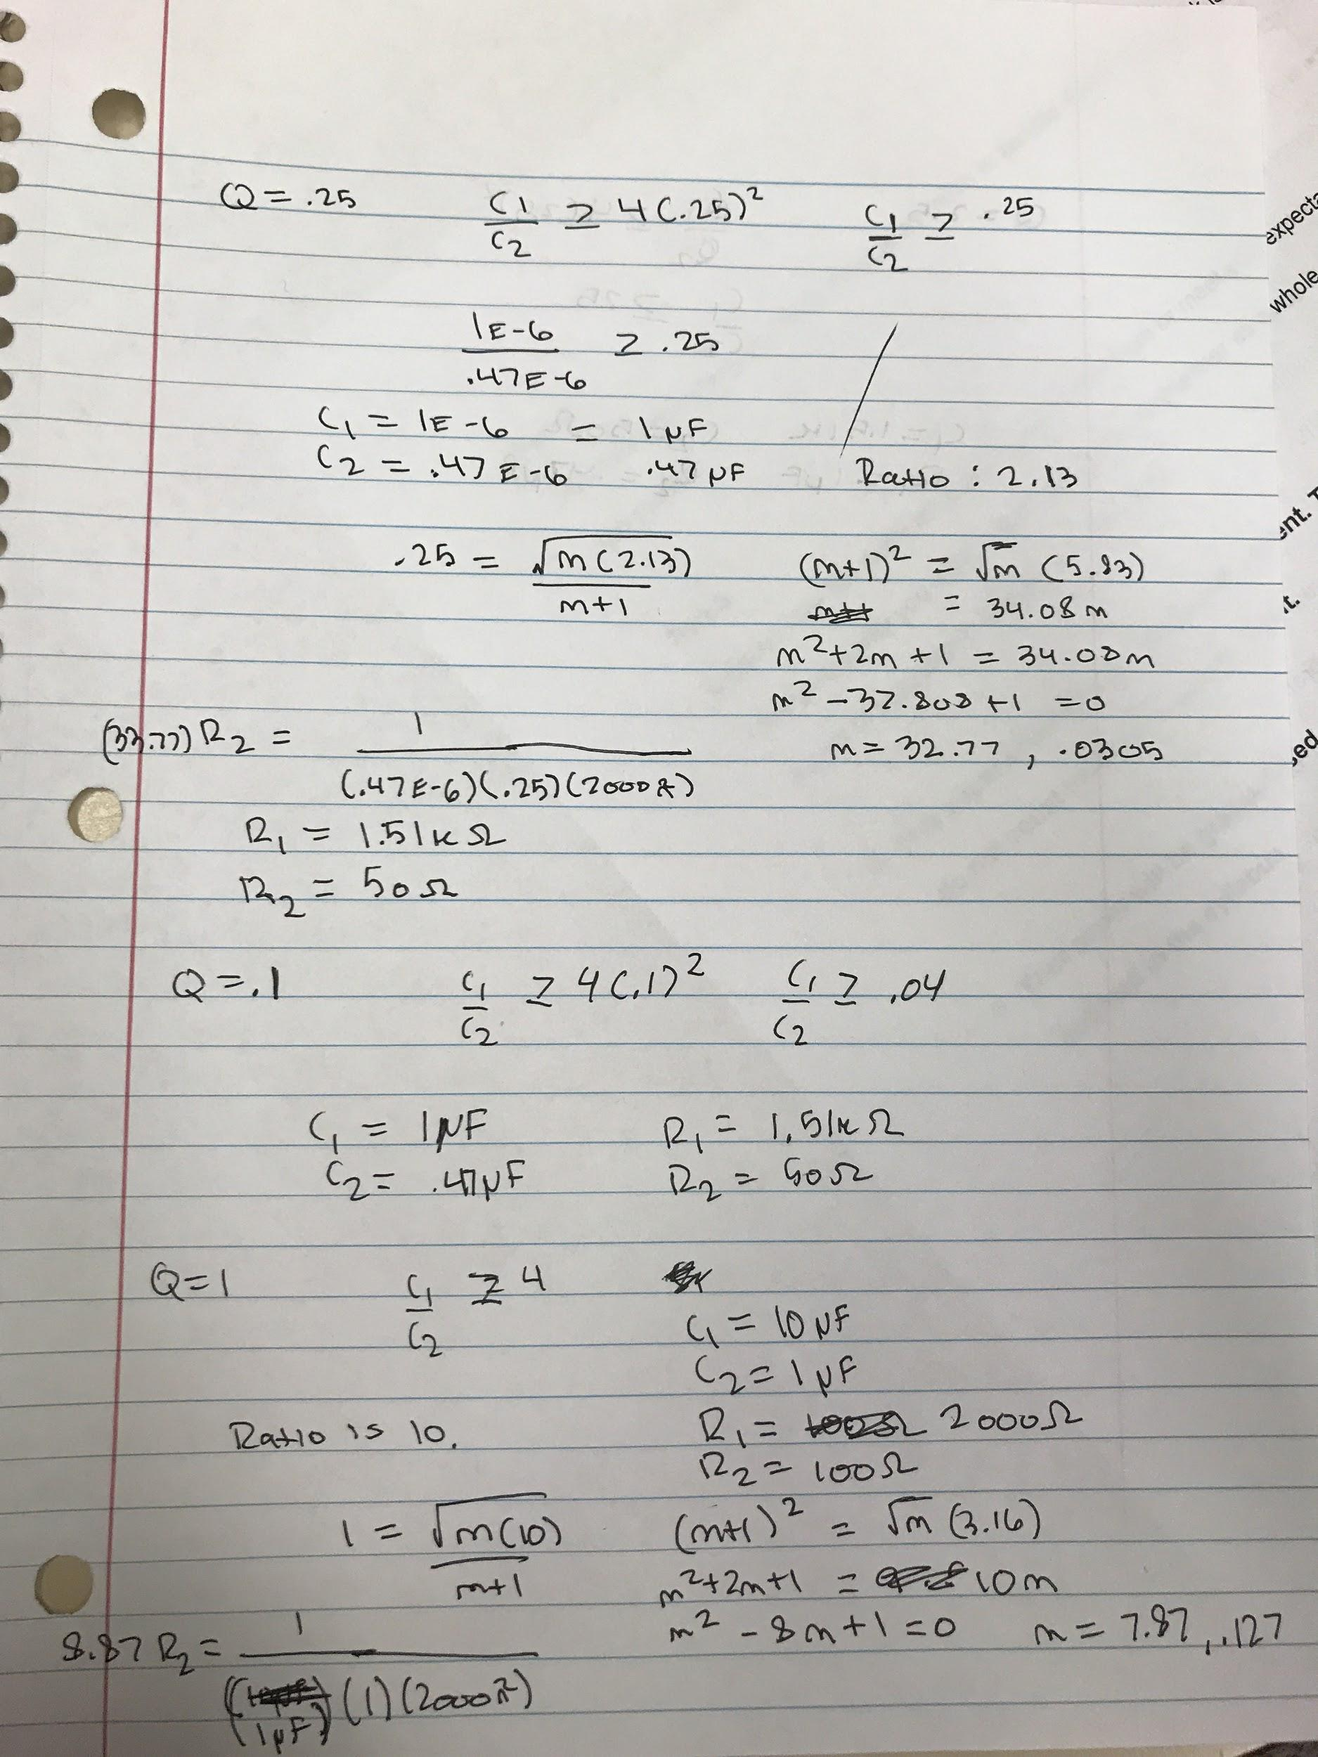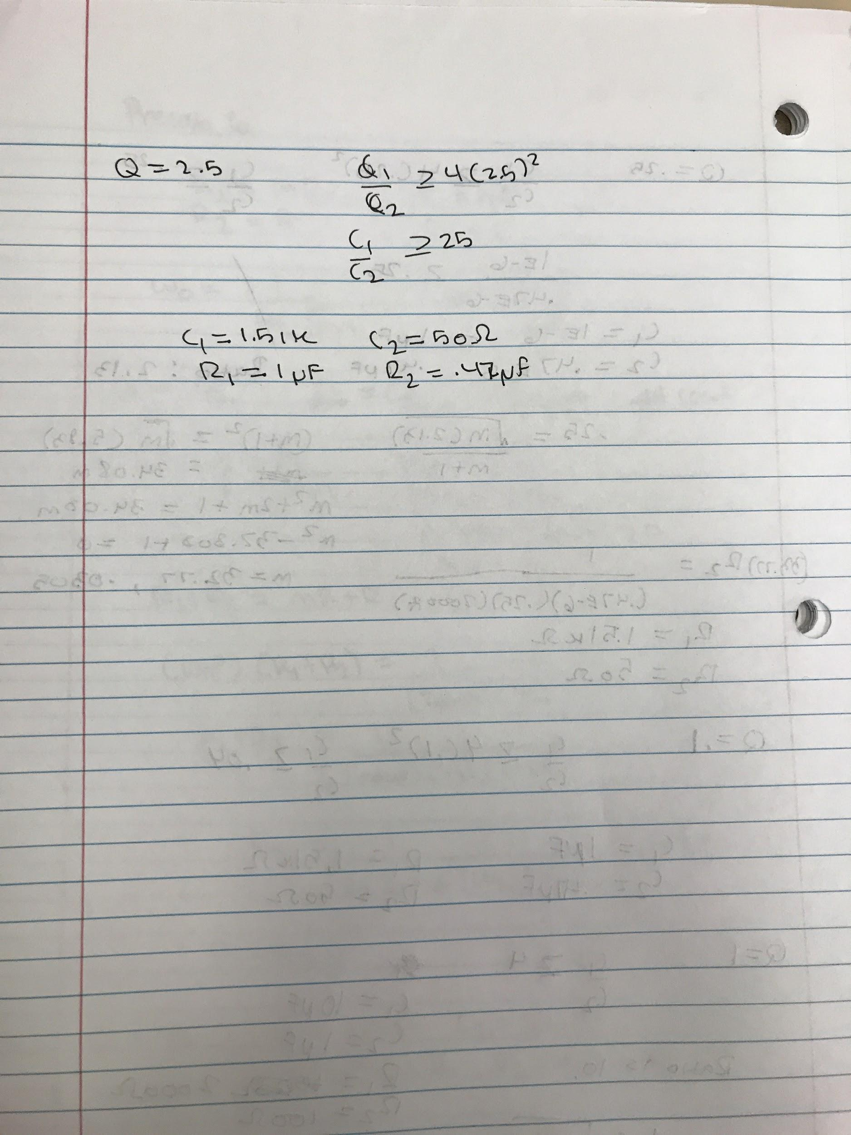

b)

Q = .5

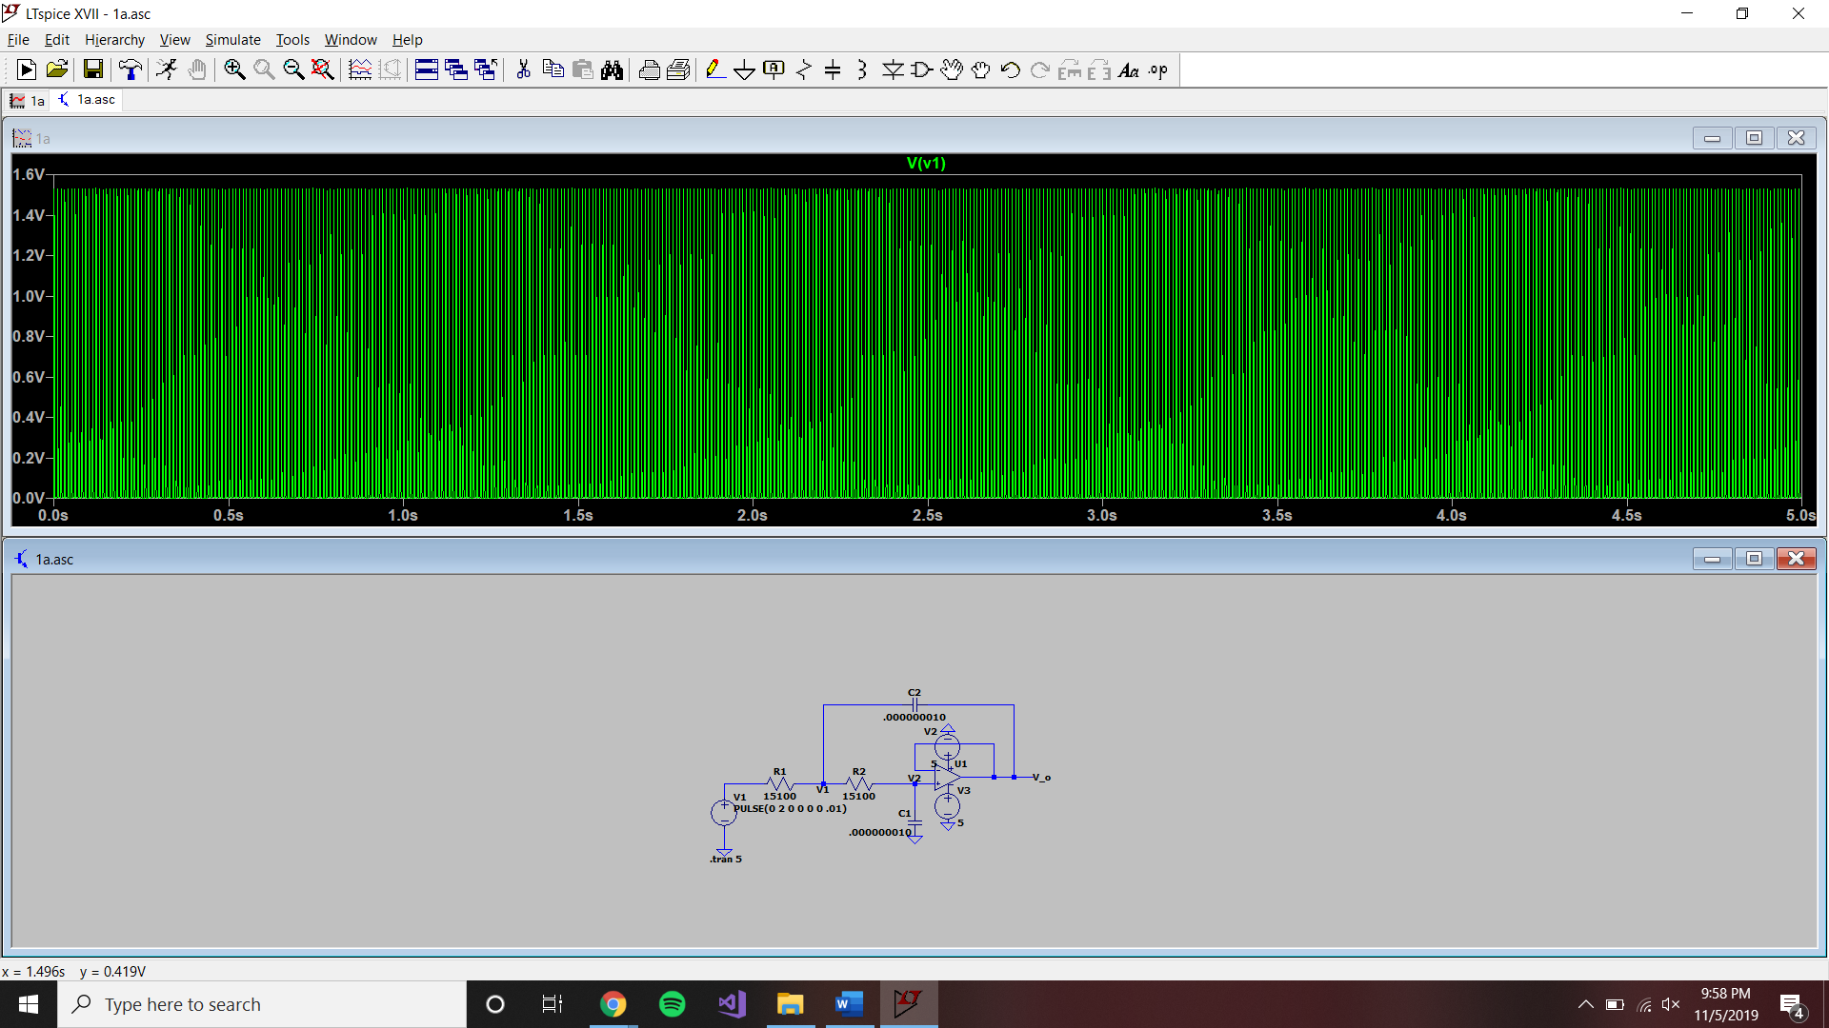

Q = .25

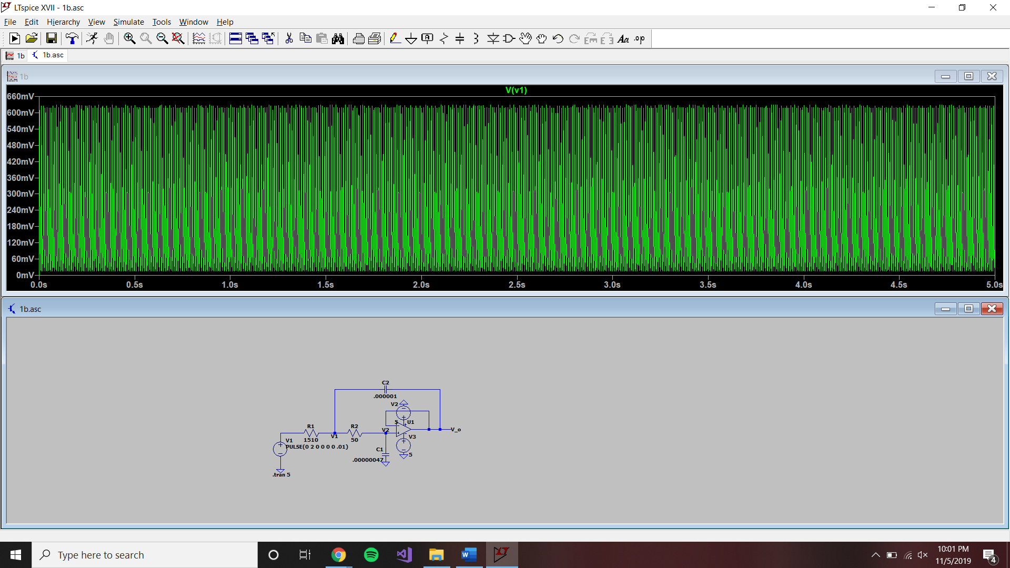

Q = .1



Q = 1

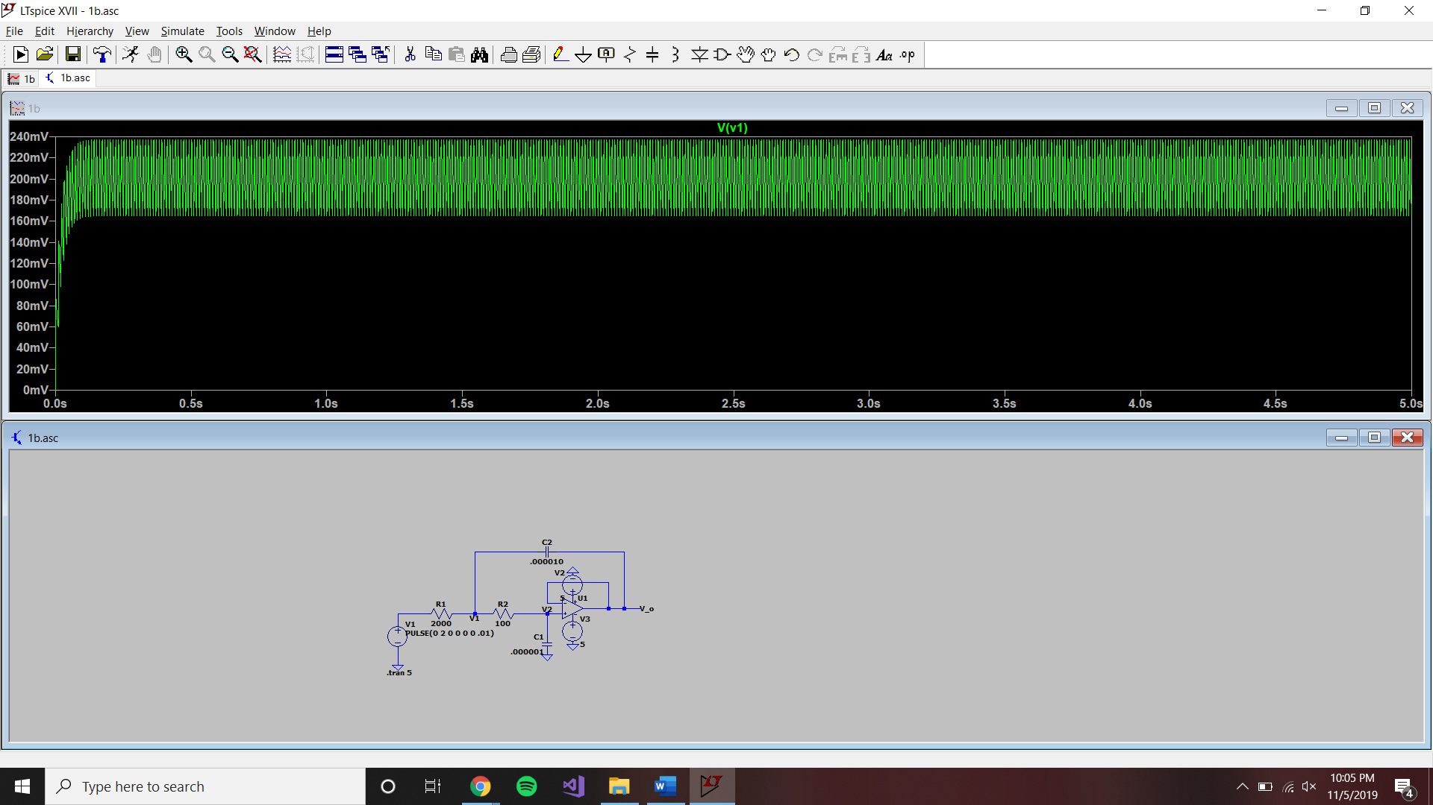

Q = 2.5